
MEMORANDUM

To: | Charlie Refvem, Lecturer, Department of Mechanical Engineering, Cal Poly SLO
 | crefvem@calpoly.edu
From: | Quinn Patterson
 | qpatters@calpoly.edu
 | Jake Rowen
 | jhrowen@calpoly.edu
Team:  Date: | 23  3/05/26
RE: | Lab 0x06 Memo

Table of Contents
- Memo Body
- Source Code

Memo Body

The state estimator will be useful tool to control Romi’s speed when not in line following mode. We used the IMU mode to access gyroscope and accelerometer data. These measurements coupled with encoder counts and motor command voltages allow us to make useful state predictions of Romi. To get a strong baseline about where Romi should be in testing, we used our line follower code to have Romi trace a circle. Our predicted location was fairly accurate, only deviating at beginning of the data. This deviation is to be expected since the initial input matrix for the state estimator is all zeros, meaning the estimator needs data accurately estimate the state. Our track path can be viewed in the figure below. The observed state consists of Arc length, heading angle, and rotational velocities for each motor. The first two can be used to estimate the location of the robot, as we did in our graph.

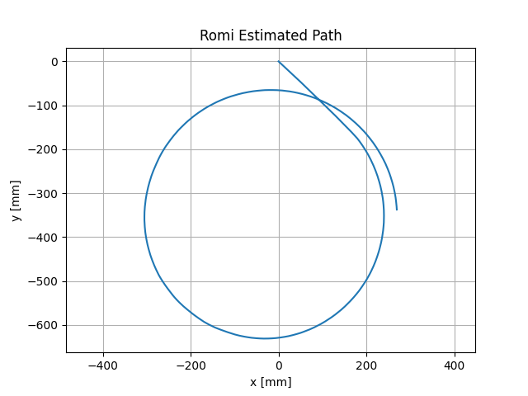
Figure 1. Romi State Estimation of Circular Path

We implemented two new tasks: a read sensor task and state estimator task. Read sensor pulls data from the IMU, Encoders, and Motors and stores them in shares for use in our u* matrix. They are then transferred via shares to the state estimator task which handles our estimation. An updated diagram of our tasks and FSMs can be viewed below. A class was written for the IMU that is references in the read sensor task. Additionally, two new queues are used for storing arc length and heading angle data from the state estimation task, which we used to create the above plot. The parameters from most recent estimated state are also stored in shares however are currently unused in our code.

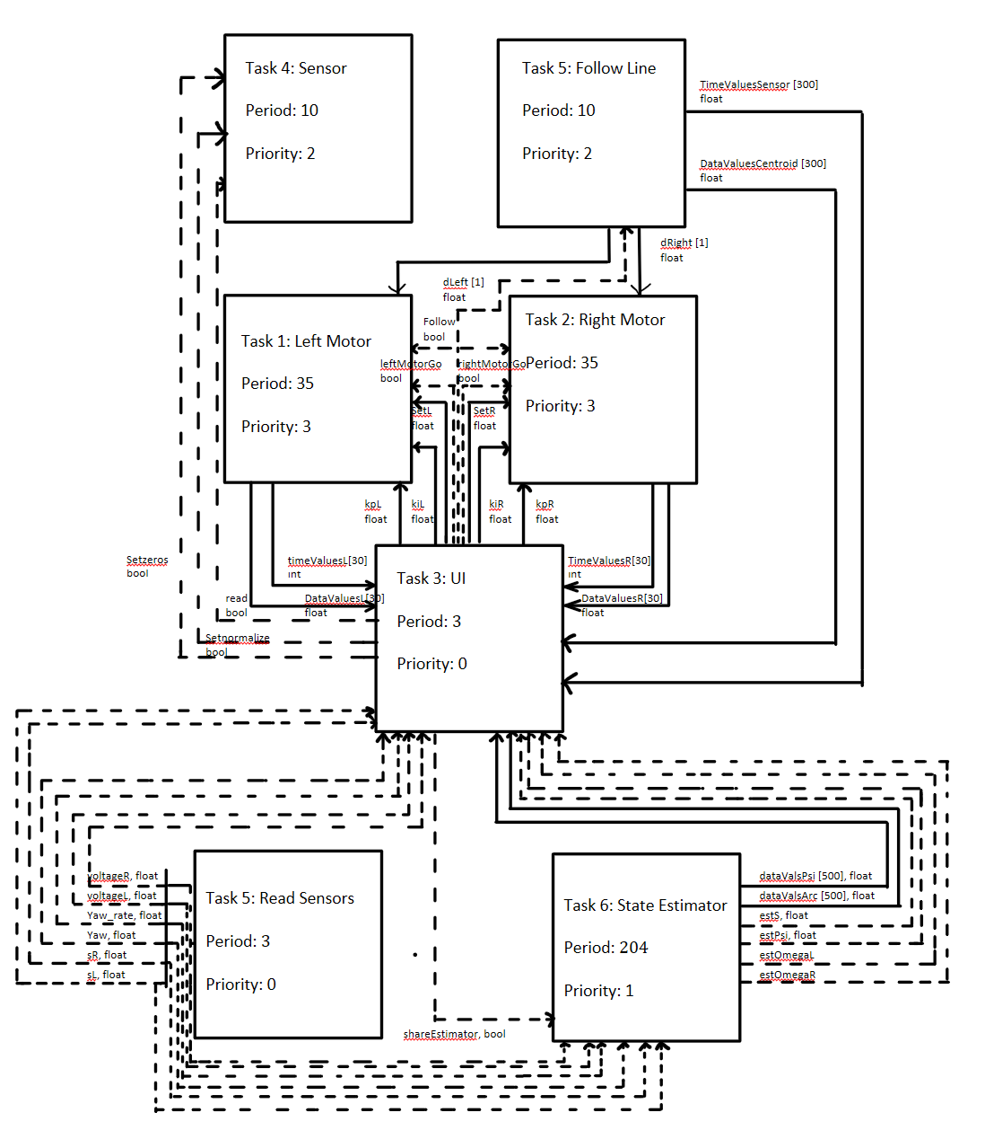
Figure 2. Task Diagram

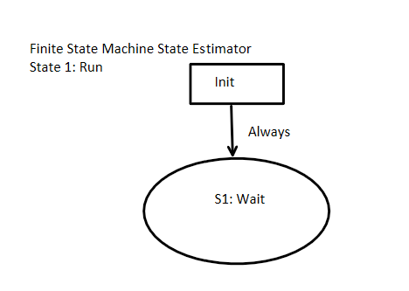
Figure 3. FSM for Sensor Task

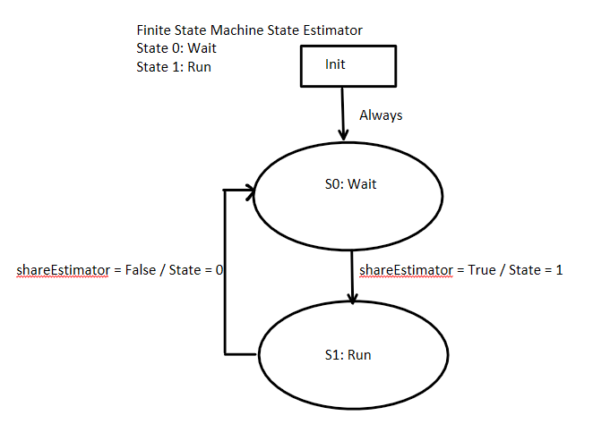
Figure 4. FSM for Estimator Task

Source Code

IMU_class.py:
import pyb
from pyb import I2C
from micropython import const
from time import sleep_ms
import os

# --- I2C address options ---
ADDR_A = const(0x28)
ADDR_B = const(0x29)

# --- Registers (subset) ---
CHIP_ID = const(0x00)
PAGE_ID = const(0x07)

ACC_DATA_X_LSB = const(0x08)
MAG_DATA_X_LSB = const(0x0E)
GYR_DATA_X_LSB = const(0x14)
EULER_H_LSB = const(0x1A)
QUA_W_LSB = const(0x20)
LIA_DATA_X_LSB = const(0x28)
GRV_DATA_X_LSB = const(0x2E)

ACC_OFF_X_LSB = const(0x55)
MAG_OFF_X_LSB = const(0x5B)
GYR_OFF_X_LSB = const(0x61)
ACC_RAD_LSB = const(0x67)

CALIB_STAT = const(0x35)

OPR_MODE = const(0x3D)
PWR_MODE = const(0x3E)
SYS_TRIGGER = const(0x3F)
UNIT_SEL = const(0x3B)

# --- Operation modes ---
MODE_CONFIG = const(0x00)
MODE_NDOF = const(0x0C) # fusion: accel+gyro+mag
MODE_IMU = const(0x08)

# --- Power modes ---
POWER_NORMAL = const(0x00)

class IMU:
def __init__(self, i2c, addr=ADDR_A):
# Using I2C2, device address is 0x28
self._i2c = i2c
self._addr = addr
self._buf = bytearray(8)

def readbyte(self, reg):
return self._i2c.mem_read(1, self._addr, reg)[0]
def readbytes(self, n, reg):
return self._i2c.mem_read(n, self._addr, reg)
def writebytes(self, val, reg):
self._i2c.mem_write(bytes([val & 0xFF]), self._addr, reg)
def write2bytes(self, val, reg):
val &= 0xFFFF
lsb = val&0xFF
msb = (val >> 8) & 0xFF
self.writebytes(lsb,reg)
self.writebytes(msb,reg+1)
@staticmethod
def combine(lsb, msb):
v = (msb<<8) | lsb
return v-65536 if v & 0x8000 else v

def read_vector(self, startreg, unit_scale):
data = self.readbytes(6, startreg)
x = self.combine(data[0], data[1]) / unit_scale
y = self.combine(data[2], data[3]) / unit_scale
z = self.combine(data[4], data[5]) / unit_scale
return x,y,z
def set_mode(self, mode):
self.writebytes(mode, OPR_MODE)
sleep_ms(30)
def initialize(self, mode=MODE_IMU, reset=True, units = 0x06):
# units 0x00 gives m/s^2, degrees/sec, Celcius
self.writebytes(0x00, PAGE_ID)
sleep_ms(5)
self.set_mode(MODE_CONFIG)
# Power Mode: Normal
self.writebytes(POWER_NORMAL, PWR_MODE)
sleep_ms(20)
self.writebytes(units, UNIT_SEL) # select standard units
sleep_ms(10)
# Calibration data
fname = "calibration.txt"
try:
os.stat(fname)
with open(fname, 'r') as file:
constants = file.read().strip().split(',')
vals = [int(c) for c in constants if c!=""]
ACC = vals[0:3]
MAG = vals[3:6]
GYR = vals[6:9]
ACC_RAD = vals[9]
MAG_RAD = vals[10]
self.write_coeff(ACC, MAG, GYR, ACC_RAD, MAG_RAD)
except OSError:
self.set_mode(MODE_NDOF)
while(True):
stat = self.calibration_status()
print(stat)
if all(bit == 3 for bit in stat[1:]):
print("Calibration complete")
break
self.set_mode(MODE_CONFIG)
ACC_OFF, MAG_OFF, GYR_OFF, ACC_RAD, MAG_RAD = self.get_coeff()
lst = list(ACC_OFF) + list(MAG_OFF) + list(GYR_OFF) + [ACC_RAD, MAG_RAD]
with open(fname, 'w') as file:
file.write(','.join(str(c) for c in lst)+ "\n")
self.set_mode(mode) # enter IMU mode
def calibration_status(self, reg=CALIB_STAT):
# data in the order: system, gyro, accelerometer, magnetometer
cbt = self.readbyte(reg)
system = (cbt >> 6) & 0b11
gyro = (cbt >> 4) & 0b11
acc = (cbt >> 2) & 0b11
mag = cbt & 0b11
return [system, gyro, acc, mag]
def get_coeff(self,reg=ACC_OFF_X_LSB):
# format: [x data, y data, z data]
raw = self.readbytes(22, reg)
ACC_OFF = (self.combine(raw[0],raw[1]) & 0xFFFF,self.combine(raw[2],raw[3]) & 0xFFFF,self.combine(raw[4],raw[5]) & 0xFFFF)
MAG_OFF = (self.combine(raw[6],raw[7]) & 0xFFFF,self.combine(raw[8],raw[9]) & 0xFFFF,self.combine(raw[10],raw[11]) & 0xFFFF)
GYR_OFF = (self.combine(raw[12],raw[13]) & 0xFFFF,self.combine(raw[14],raw[15]) & 0xFFFF,self.combine(raw[16],raw[17]) & 0xFFFF)
ACC_RAD = self.combine(raw[18],raw[19]) & 0xFFFF
MAG_RAD = self.combine(raw[20],raw[21]) & 0xFFFF
return ACC_OFF,MAG_OFF,GYR_OFF,ACC_RAD,MAG_RAD
def write_coeff(self, ACC, MAG, GYR, ACC_RAD, MAG_RAD, reg=ACC_OFF_X_LSB):
self.write2bytes(ACC[0], reg)
self.write2bytes(ACC[1], reg+2)
self.write2bytes(ACC[2], reg+4)
self.write2bytes(MAG[0], reg+6)
self.write2bytes(MAG[1], reg+8)
self.write2bytes(MAG[2], reg+10)
self.write2bytes(GYR[0], reg+12)
self.write2bytes(GYR[1], reg+14)
self.write2bytes(GYR[2], reg+16)
self.write2bytes(ACC_RAD, reg+18)
self.write2bytes(MAG_RAD, reg+20)
def euler(self, reg=EULER_H_LSB):
angles = self.read_vector(reg, 900.0)
return angles
def ang_v(self, reg=GYR_DATA_X_LSB):
rates = self.read_vector(reg, 900.0)
return rates
def accel(self, reg=ACC_DATA_X_LSB):
accel = self.read_vector(reg, 100)
return(accel)

task_read_sensor.py:
from IMU_class import IMU
from encoder_class import Encoder
from task_share import Share
from micropython import const
from motor_class import Motor

S1_RUN = const(1)

class read_sensors:
def __init__(self, IMU, EncoderL, EncoderR, MotorL, MotorR, sL, sR, yaw, yaw_rate, voltageL, voltageR):
self.IMU : IMU = IMU
self.EncoderL : Encoder = EncoderL
self.EncoderR : Encoder = EncoderR
self.MotorL : Motor = MotorL
self.MotorR: Motor = MotorR
self.sL : Share = sL
self.sR : Share = sR
self.yaw : Share = yaw
self.yaw_rate : Share = yaw_rate
self.voltageL : Share = voltageL
self.voltageR : Share = voltageR
self._state = S1_RUN
def run(self):
while(True):
if self._state == S1_RUN:
self.sL.put(self.EncoderL.get_position())
self.sR.put(self.EncoderR.get_position())
self.yaw.put(self.IMU.euler()[0])
self.yaw_rate.put(self.IMU.ang_v()[2])
self.voltageL.put(self.MotorL.get_voltage())
self.voltageR.put(self.MotorR.get_voltage())
yield self._state

task_estimate_state.py:
from IMU_class import IMU
from encoder_class import Encoder
from ulab import numpy as np
from micropython import const
from task_share import Share, Queue

S0_WAIT = const(0)
S1_RUN = const(1)

#shareEstimator is a share that sets the state of this task accordingly

class state_est_task:
def __init__(self, sL, sR, voltageL, voltageR, yaw, yaw_rate, shareEstimator, estS, estPsi, estOmegaL, estOmegaR, dataValsArc, dataValsPsi):
self.sL : Share = sL
self.sR : Share = sR
self.voltageL : Share = voltageL
self.voltageR : Share = voltageR
self.yaw : Share = yaw
self.yaw_rate :Share = yaw_rate
self.dataValsArc : Queue = dataValsArc
self.dataValsPsi : Queue = dataValsPsi
self._state = S0_WAIT
self._shareEst : Share = shareEstimator
self._estS : Share = estS
self._estPsi : Share = estPsi
self._estOmegaL : Share = estOmegaL
self._estOmegaR : Share = estOmegaR
self._encLInitial = 0
self._encRInitial = 0
self._headingInitial = 0
self._xhat = np.zeros((4,1), dtype = np.float) # initialize state vector
self._AD = np.array([[0.7427, 0, 0.2494, 0.2494],[0, 0.0061, 0, 0],[-0.1212, 0, 0.3192, 0.3095],[-0.1212, 0, 0.3095, 0.3192]],dtype = np.float)
self._BD = np.array([[0.1962, 0.1962, 0.1287, 0.1287, 0, 0],[0, 0, -0.0071, 0.0071, 0.0001, 0.0039],[0.7137, 0.4156, 0.0606, 0.0606, 0, -1.8098],[0.4156, 0.7137, 0.0606, 0.0606, 0, 1.8098]],dtype = np.float)
self._CD = np.array([[1, -70, 0, 0],[1, 70, 0, 0],[0, 1, 0, 0],[0, 0, -0.25, 0.25]], dtype = np.float)
self._DD = np.array([[0, 0, 0, 0, 0, 0],[0, 0, 0, 0, 0, 0],[0, 0, 0, 0, 0, 0],[0, 0, 0, 0, 0, 0]], dtype = np.float)
def run(self):
while(True):
if self._state == S0_WAIT:
if self._shareEst.get() == True:
self._state = S1_RUN
elif self._state == S1_RUN:
u_star = np.array([[self.voltageL.get()],[self.voltageR.get()],[self.sL.get()],[self.sR.get()],[self.yaw.get()],[self.yaw_rate.get()]], dtype = np.float)
xhat_new = np.dot(self._AD, self._xhat)+np.dot(self._BD, u_star)
yhat = np.dot(self._CD, self._xhat) + np.dot(self._DD, u_star)
self._xhat = xhat_new
self._estS.put(float(xhat_new[0,0]))
self._estPsi.put(float(xhat_new[1,0]))
self._estOmegaL.put(float(xhat_new[2,0]))
self._estOmegaR.put(float(xhat_new[3,0]))
if self._shareEst.get() == False:
self._state = S0_WAIT
if not self.dataValsArc.full():
self.dataValsArc.put(float(xhat_new[0,0]))
if not self.dataValsPsi.full():
self.dataValsPsi.put(float(xhat_new[1,0]))
yield self._state

